Question 1

IOM1

B3-Control register

B2 –Port C

B1-Port B

B0-Port A; Output Port

IOM2

D3-Control register

D2 –Port C

D1-Port B; Input Port

D0-Port A

Control Word:

IOM1: 1000 0000=80H

IOM2: 1000 0010=82H

1. MVI A, 80H

OUT B3H

MVI A, 82H

OUT D3H

1. IN D1

STA A001H

CMA

OUT B0H

HLT

Question 2

1. [0.5 marks for each]

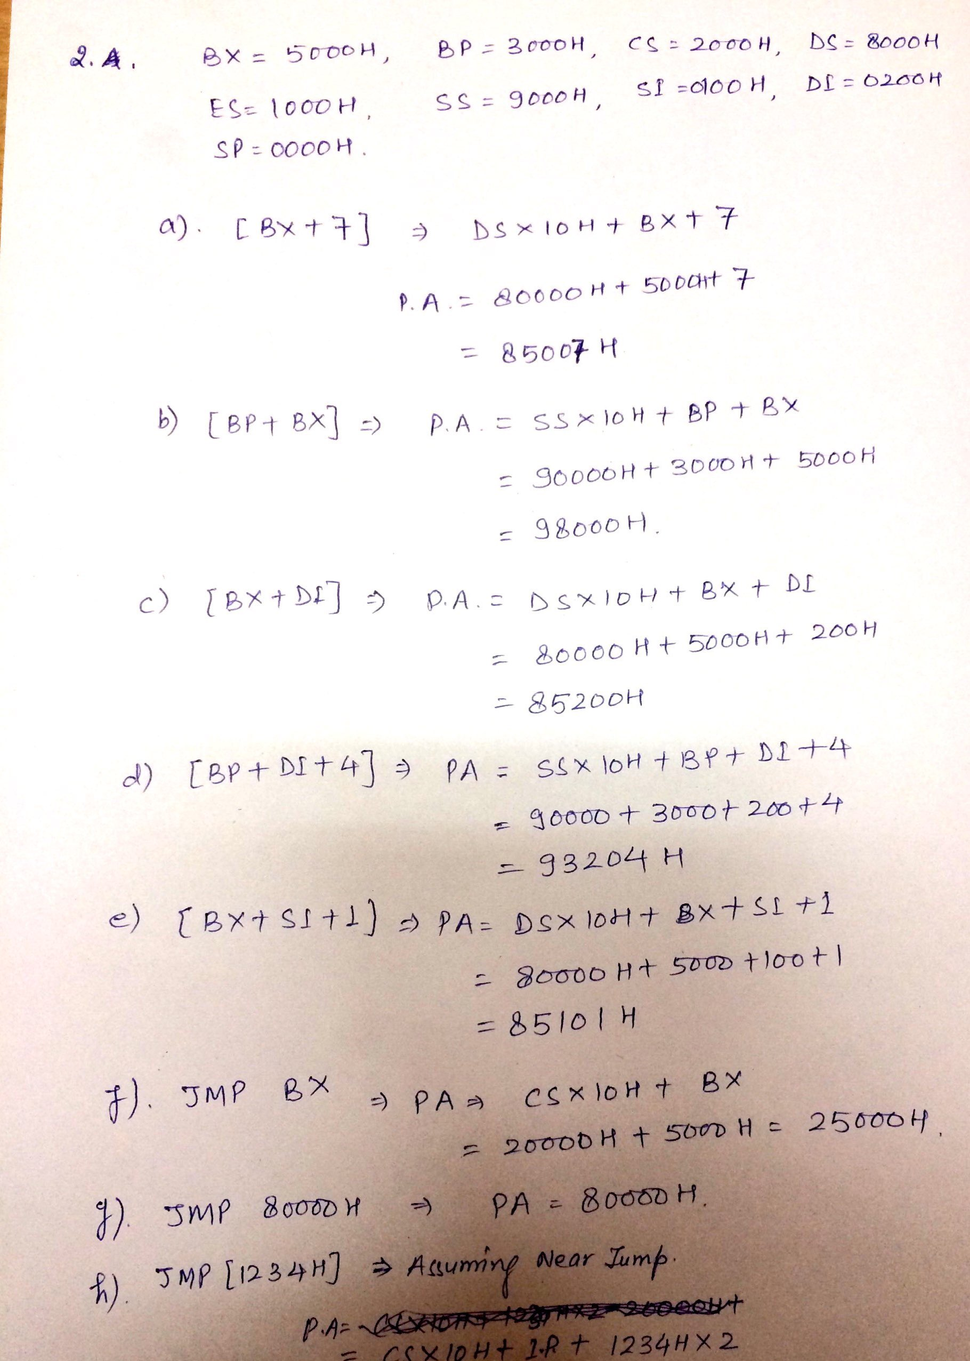

1. [0.5 marks for each]

Question 4

1. [marks 2+2]

Clock cycles=13

1 2 3 4 5 6 7 8 9 10 11 12 13

IF OF PO PO PO WB

IF OF PO PO PO PO PO WB

IF OF PO WB

IF OF PO WB

1. [marks 2+2]Exe time for Pipeline= 13\* 10

130 nsec

Exe time for Non-Pipeline= 22\* 10

220 nsec

Question 5

1. Tag- line number -word

1. Direct 16 – 10 – 4. (2 marks)
2. 2-way set 17 – 9 – 4. (2 marks)
3. Fully Associative 26 – 0 – 4. (1 marks)
4. (2 marks for hit ratio and 2 marks for average access time)

